Custom PCB Implementation
of
FPGA-Based Lane Detection using Sobel Filter
Project summary: This document describes the transition from the working Nexys A7 FPGA prototype to a simplified custom PCB concept. The PCB provides the external hardware around the FPGA, while the Sobel lane edge detection VHDL design still runs inside the FPGA.

Block Diagram
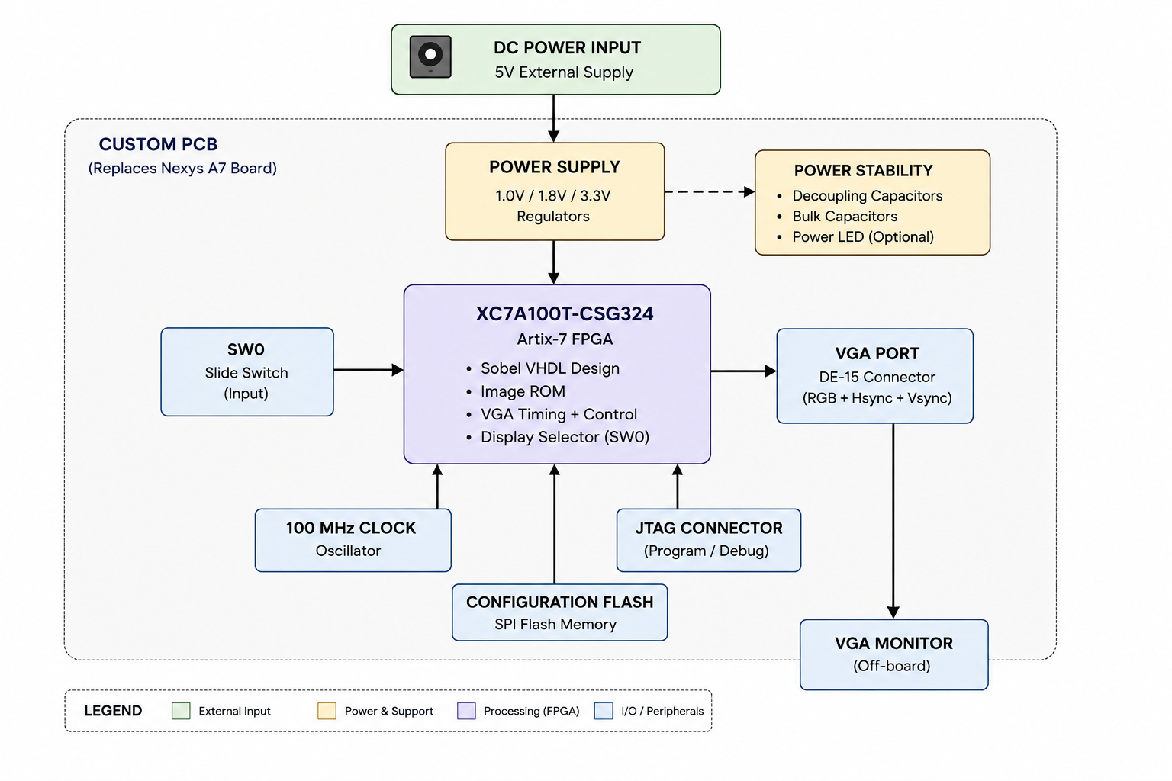
Figure 1: FPGA-to-PCB block diagram for the Sobel lane edge detection project.

Goal
The goal is to convert the FPGA-based Sobel lane edge detection prototype into a simplified custom PCB concept.
The VHDL design was first implemented and tested on the Nexys A7 board. The PCB design then identifies the required hardware blocks of the development board and recreates only the parts needed for this project.
The custom PCB does not replace the FPGA logic. It replaces the development board hardware around the FPGA, such as power, clock, VGA, SW0, programming, configuration flash, and power stabilization.

Tasks
- Analyze the existing FPGA prototype and identify required external signals.
- Select the main FPGA device: Artix-7 XC7A100T-CSG324.
- Define the PCB system architecture and block diagram.
- Create schematic pages for FPGA, power, clock, JTAG/configuration flash, SW0, and VGA output.
- Connect the required VHDL ports to real PCB components.
- Add 1.0 V, 1.8 V, and 3.3 V power supply rails.
- Add decoupling capacitors close to FPGA power pins.
- Add an optional power LED for basic debugging.
- Transfer the schematic to PCB layout in Altium.
- Place components, route important connections, add polygon pours, and generate PCB outputs such as BOM and Gerber files.

Requirements

Functional Requirements
- The FPGA must receive a stable 100 MHz clock.
- The FPGA must receive correct supply voltages: 1.0 V, 1.8 V, and 3.3 V.
- SW0 must be connected as a user input for display selection.
- The FPGA must output VGA RGB signals and synchronization signals to a VGA connector.
- The board must include a programming interface through JTAG.
- The board should include configuration flash memory for storing the bitstream.
- Decoupling capacitors must be included for power stability.

Non-Functional Requirements
- The design should be simple enough to explain and suitable for an educational PCB project.
- The schematic should be modular and easy to read.
- The PCB layout should show clear component placement and basic routing.
- The final output should include schematic, layout, 3D view, BOM, and Gerber files.
- The PCB is a simplified concept board and not a fully production-verified BGA FPGA board.

FPGA Resources
Resource | Purpose in the Project
Logic elements / LUTs | Used for VGA timing, Sobel calculation, control logic, and display selection.
Flip-flops | Used for counters, registers, synchronization signals, and pipeline stages.
Block RAM / ROM | Used to store the grayscale road image inside the FPGA.
Clock input | Receives the 100 MHz oscillator signal.
I/O pins | Used for SW0 input and VGA output signals.
Configuration interface | Used for programming the FPGA and loading the bitstream.
Power pins | Used for FPGA core, auxiliary, and I/O power rails.

Required Components

Inputs
Input Component | Purpose
SW0 slide switch | Selects between original image and Sobel edge output.
100 MHz oscillator | Provides the main clock signal for the FPGA.
JTAG connector | Allows programming and debugging of the FPGA.
Configuration flash | Stores the FPGA bitstream for automatic configuration after power-up.

Outputs
Output Component | Purpose
VGA connector / DE-15 | Displays the original image or Sobel edge result on a VGA monitor.
VGA RGB resistor network | Converts digital FPGA color outputs into approximate analog VGA color levels.
Hsync and Vsync lines | Synchronize the VGA monitor with the FPGA video output.
Optional power LED | Shows that the board is powered.

Processing
Processing Component | Purpose
Artix-7 XC7A100T-CSG324 FPGA | Main processing device that runs the Sobel VHDL design.
Image ROM inside FPGA | Stores the 160 x 120 grayscale road image.
VGA timing logic | Generates screen coordinates, Hsync, Vsync, and visible area.
Sobel filter logic | Detects edges by processing the image pixel stream.
Display selector logic | Uses SW0 to choose original image or Sobel output.

Power and Stability
Component | Purpose
1.0 V regulator | Supplies FPGA core voltage.
1.8 V regulator | Supplies FPGA auxiliary/configuration voltage.
3.3 V regulator | Supplies FPGA I/O, oscillator, switch, VGA, and JTAG voltage.
Decoupling capacitors | Stabilize the FPGA power rails and reduce switching noise.
Bulk capacitors | Support the power regulators and reduce voltage drops.
Ground polygon pour | Provides stable ground connection and improves PCB performance.

System Working Principle
- The 100 MHz oscillator provides the system clock to the Artix-7 FPGA.
- Inside the FPGA, the VHDL design reads a stored grayscale road image from ROM.
- The VGA timing logic generates the current pixel position and synchronization signals.
- The Sobel filter detects strong brightness changes in the image, which represent edges.
- SW0 selects whether the VGA monitor displays the original image or the Sobel output.
- The custom PCB provides all required external hardware: power rails, clock source, switch input, VGA output, JTAG programming, configuration flash, and power stabilization.

Summary
This PCB design is a simplified custom FPGA board concept for the Sobel lane edge detection project. The FPGA performs the image processing, while the PCB provides the required external hardware. The design is based on the working Nexys A7 prototype and focuses only on the components needed for this project.

